60 % **Investigation Work Book**

How is it that artist’s can show movement within a painting or a sculpture? What techniques do they use to show speed, or an object moving closer or running away?

And why would an artist want to show these things?

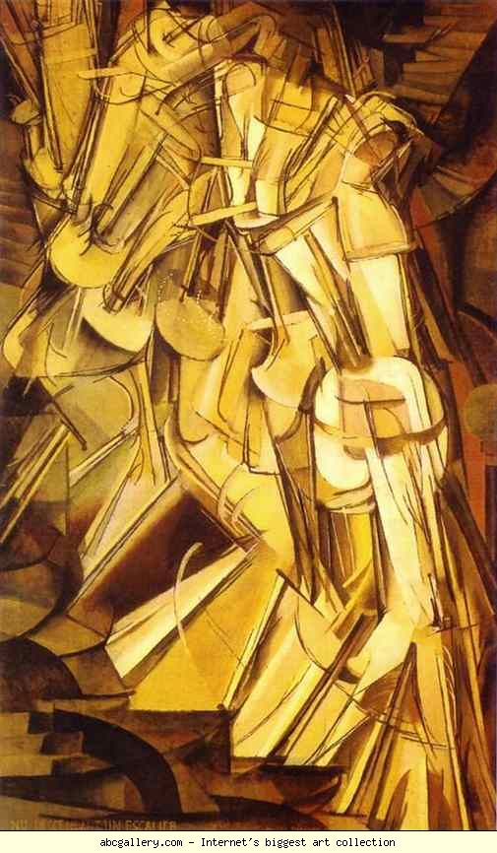

UNIT 4

Static Movement

**Research across a variety of times, cultures and in different medias about how artists show movement in their work. Compare their techniques and consider why they were using them. Think about the context of the artist.**

**TASKS**

**Think back to your last project. What about it was personally relevant to you? Particularly think about your culture. What imagery was very successful and what will you give movement to? Why is it moving? Take video to help you to study how your topic moves.**

**Experiment with similar techniques and processes as the artists you’ve studied. Try in a variety of media to express movement to your chosen topic. This may include photography, drawing, painting, sculpture.**

**Select your most successful techniques that explore your ideas and demonstrate your intentions. Use this to influence designs for 3-dimentional paper constructions.**

**Experiment with a variety of paper construction. Use paper cut and cardboard construction artist to help you understand how.**

**Studio Work = 4­0%**

**Presentation Criteria – (Considered on every page)**

**Vocabulary**

Demonstrate careful and accurate use of the specialist vocabulary of visual arts.

**Acknowledge Sources**

Use an appropriate range of sources and acknowledge them properly.

**Presentation**

Presents the work effectively and creatively and demonstrates some good critical observation and reflection.

**Integration**

Present work effectively and creatively, demonstrating good critical observation and reflection.

**Research Criteria**

**Culture and Context**

Analyse and compare, art from different cultures and times, carefully consider the function and significance.

**Technical Process**

Demonstrate the development

of effective skills, techniques

and processes when making

and analysing images and

artifacts.

**Investigation**

Demonstrate coherent and

focused investigative strategies into visual qualities, ideas and their contexts. Use a range of approaches towards their study, and make connections between them.

**Depth and Breath**

Demonstrate depth and

breadth through a mostly

successful development of ideas and explain connections

between the your work and that of artists.

**Final Piece Criteria**

**Understanding**

Exhibit clear understanding

of the ideas and techniques that underpin artistic expression

**Relevance**

Consistently demonstrate the

production of personally relevant artworks that show exploration of ideas reflecting

cultural and historical

awareness and artistic qualities.

**Development**

Show thoughtful development

of ideas and strategies for

expression.

**Sensitivity**

Display sensitivity to materials

and their use. Review,

modify and refine your work as it progresses, resolving your ideas and media.

**Technique**

Display excellent technical

Competence.

**Confidence**

Demonstrate confidence and

inventiveness.

**Independence**

Shows an informed, reflective

judgment that challenges and

extends personal boundaries.

**Appropriate Resources Relevant Artists**

**Final Task**

Develop a range of personally relevant studio work in 2D and 3D that explores movement.

**Things to Consider**

Have I put in appropriate time and energy?

Have I truly explored my ideas to create interesting, adventurous studio work (or have I just settled for the obvious)? Have I used any unusual or unexpected combinations of ideas or materials in my studio work?

How are the ideas in my studio work connected with my own life and cultural background? Have I created strong, powerful pieces of art work which *really mean something* to me?”

Are the ideas behind my studio work well suited to the techniques and media that I have chosen to use? What is the personal, cultural or visual meaning/purpose of my studio work?

How effectively have I designed the appearance of my studio work? Have I used visual language well? (line, composition, form, tone, colour, texture etc) Which visual or artistic problems have I encountered and have I solved them well?

Am I using my chosen media with high levels of skill? What visual effects do I want to create? How effective is the medium I have chosen at creating these effects? Would it be better to choose a different medium?”

Can I distinguish between my good and not-so-good art works, explaining how each piece has contributed to my improvement?

**Limitations**

You must have at least 2 2-dimentional works and 1 3-dimentional. Works should be made at regular intervals during your investigation.

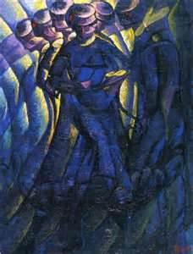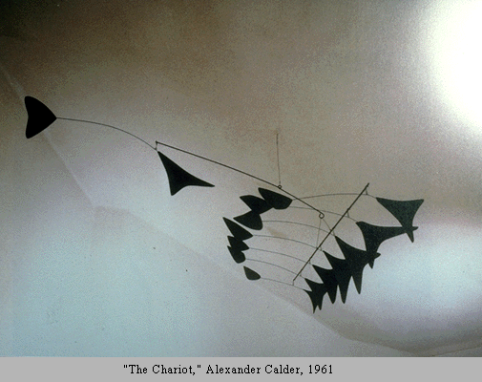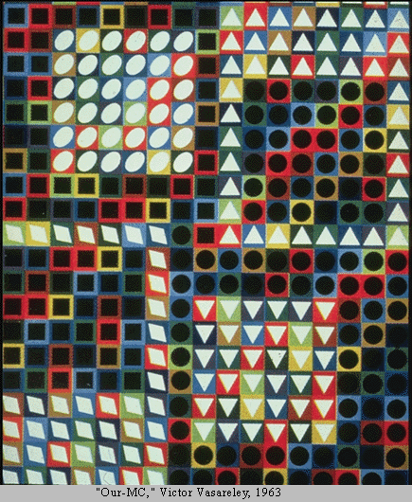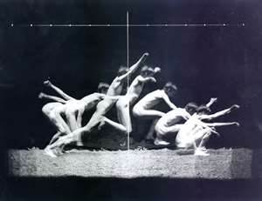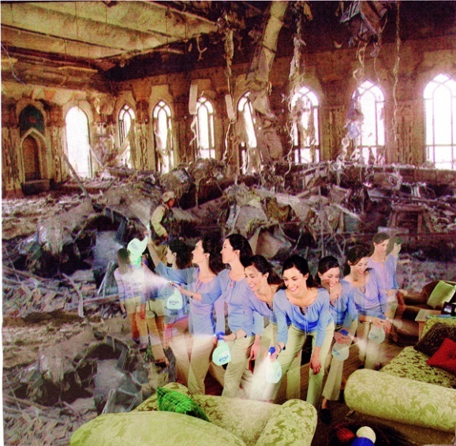Animal locomotion - Vol 4 - FEMALES (nude) - Highlights : Eadweard Muybridge - Animal locomotion volume 4 - scanned and processed by Dave Gordon

**Deadline = April Minimum Pages = 15**

**1 Studio Piece**

**Edweard Muybridge**

Ikons – Art Now Taschen

30,000 Years of Art

The history of Art

Plop

Art Monthly

Futurism

<http://www.cambridgeincolour.com/tutorials/camera-shutter-speed.htm>

http://art.sy/

<http://www.muybridge.org/>

[www.**masters-of-photography.com**/M/**muybridge**/**muybridge**.html](http://www.masters-of-photography.com/M/muybridge/muybridge.html)

<http://char.txa.cornell.edu/language/element/move/move.htm>

<http://www.theartstory.org/movement-futurism.htm>

**Alex Calder**

**Martha Kruger**

**Victor Vasareley**

Salvador Dali

Pablo Picasso

Marcel Duchamp

Edweard Muybridge

Umberto Boccioni, Carlo Carrà, and Luigi Russolo.

Alexander Calder

Bridget Riley

Victor Vasarelly

Robert Delauney

Boccioni

|  |  |
| --- | --- |
| GiacomBalla |  |

Natalia Goncharov

Luigi Russolo