HOW TO START A NEW DOCUMENT

1.Open the Photoshop Application
Click on the FILE Menu and then NEW…
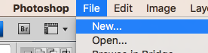
2. Name your file with your name and your class name. Then change then settings to match below.
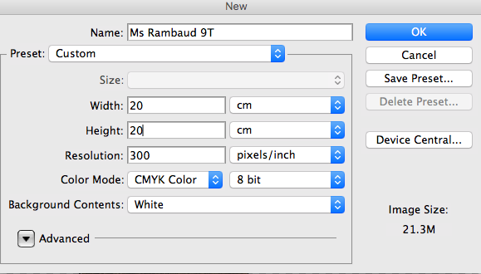
NOTE:
- 20 x 20 cm is the size you need your album cover to be
- 300 resolution and CMYK Colour is suitable for printing
- 72 resolution and RGB Colour if it is designed for a screen. (you cannot change this later without spoiling your work)

You need to cut your objects from your photos and add them into a new document

HOW TO OPEN ONE OF YOUR PHOTOS

- Open the Photoshop Application
Click on the FILE Menu and then Open…
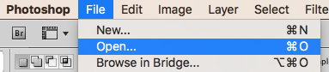
- Use the browser to find where you have saved your image.
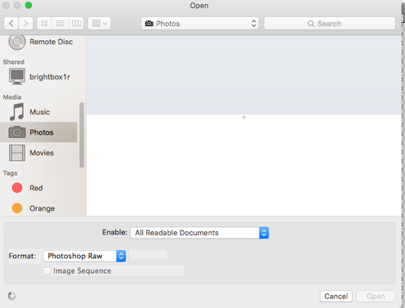
NOTE: Make sure your image is saved on the computer rather than using it from a phone or memory card, you could lose everything!

- Your image will open as a separate document and appear as a separate window or tab. Simply cut your shapes from your photos and add them onto the white new document.
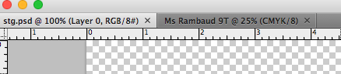

LAYERS EXPLAINED

Photoshop layers are like sheets of stacked acetate (clear paper). You can see through transparent areas of a layer to the layers below. You move a layer to position the content on the layer, like sliding a sheet of acetate in a stack. You can also change the opacity of a layer to make content partially transparent

Each image you paste into a document will automatically be a new layer.

You can click and drag the layer up and down to move their order in the layer box

You can hide layers without deleting them by clicking on the eye

Right click on the layer to delete or merge layers together

LAYER TRICKS

Opacity – You can change how ‘see-through’ an object on a layer/ an entire layer is
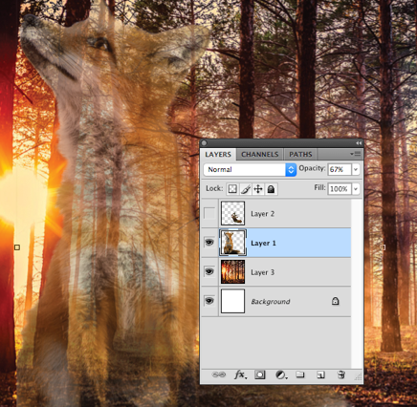
Blend Modes – Play with this drop down menu in your layers box. It Blends the layer you select with the layer below
