Select and Cut Worksheet

Option 1
- Choose the Quick Selection Tool by clicking on the 4th symbol own in the tool bar t the left of the screen
2. Hold SHIFT to Select an area and ALT to take away. You can see a ‘+’ and a ‘-‘ at the top of your screen to know which mode you are in.
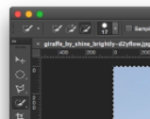
- Now hold down the left mouse button and drag over the area you want to select Don’t worry about been too accurate. You will refine the edge next.
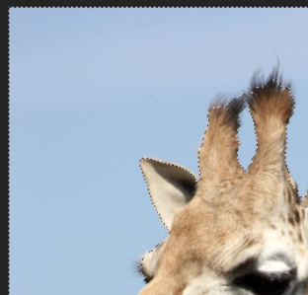
- You are going to create a layers Mask by looking at your layer menu on the right side of the screen. Click on the symbol, white rectangle with black circle in middle
PTO to refine the edge

Option 2
- Choose the magic wand tool by left clicking and holding on the quick selection tool, then selecting.
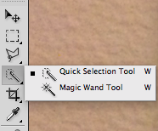
- Click on areas you want to take away. It will choose areas of similar colour.
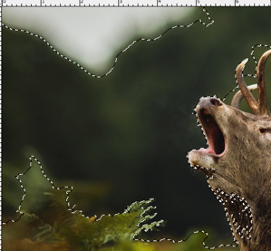
- You can change the sensitivity of this selection by increasing or decreasing the tolerance. Higher number will select more, lower less.
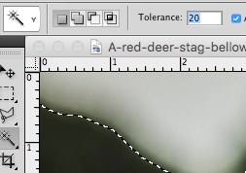
- If you want to take away from your selection, you can use the quick selection tool. Hold SHIFT and ALT whilst selecting with the left mouse button to use.
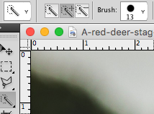
- Keeping the area selected, you’ll need to change a layer because you can’t delete out of a background.
Look at your layers menu on the right. Double click on the small padlock, it should change from ‘background’ to ‘Layer 0’.
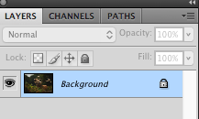

- Now when you press DELETE on your keyboard, your selected area will delete.

HOW TO REFINE THE EDGE

- The object you want to refine should be selected with
a dotted line around its edge.
- If the background is selected and not the object, then
You must go to the SELECT menu at the top
And click on INVERSE
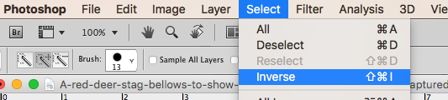
- If nothing was selected, go to your layers menu and
Hold COMMAND and click on the thumbnail image of
Your selection
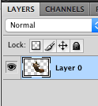
- Now that you have your selection, ensure you have the
quick selection, or magic wand tool selected and click on
REFINE EDGE at the top-middle of your screen.
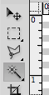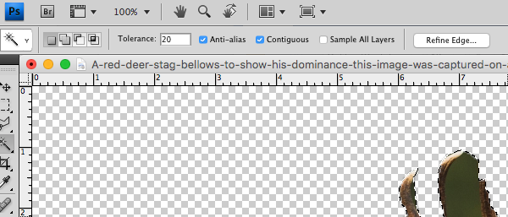
- Drag the settings bars up and down until you are happy.
Each image will be different according to their resolution
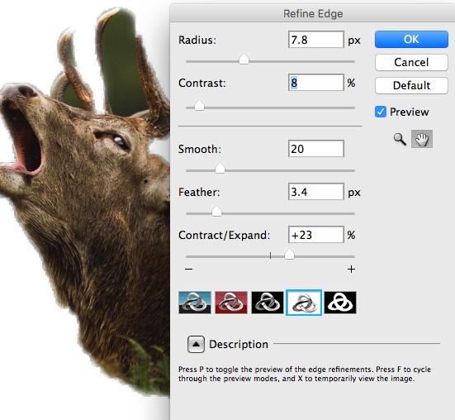
- Press OK when you are done. If your background is still
There you’ll need to Inverse the selection and delete.
(See 1A above)
Press DELETE on your keyboard to delete

HOW CUT and PASTE

- You must have your object selected with the dotted
line. (see 1B if this is not the case)
- COMMAND C is copy and COMMAND V is paste.
Or go to the EDIT menu where you’ll see Cut, Copy, Paste
