Shape and Perspective Rubric
 | 1 | 2 | 3 | 4 | 5 | Comments | Score
Perspective  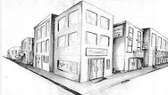 | Simple one-point perspective has been attempted |  |  |  | Unusual view point has been used to create a exciting and dynamic artwork
 | Confused shapes leaning in wrong directions |  |  |  | All line point to vanishing point. Verticals and horizontals correct. Guide lines erased
Accuracy  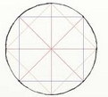 | Basic shapes appear incorrect |  |  |  | All shapes within artwork are accurately drawn at within all levels of perspective
 | Minimal detail has been applied |  |  |  | All areas of the work have considerable detail accurately applied according to perspective
Creativity | The ideas lack evidence of personal expression. |  |  |  | Highly individual, creative work inspired by a range of research. Effectively expresses desired outcome
 | Chosen to use objects found within classroom |  |  |  | Collected a range of objects that are personal and have a connection between them
Tone  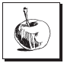 | Little or no variation of tonal techniques diminishes the visual interest of the piece. |  |  |  | Full range of tone from darkest to light applied across entire page depending on perspective
 | A little thought to where light is coming from. Tones applied randomly |  |  |  | Tones accurately placed onto shape showing consideration to light source, shadow and reflections

Name:

Total:

Grade:

