Tutorial – Fusing Plastic
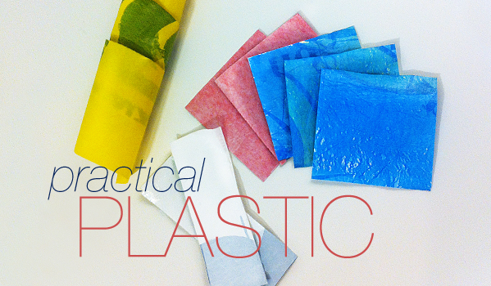
You will need:
- Baking paper (news paper works just as well in my opinion)
- A range of colourful plastic bags
- An iron
In my examples I have used folder sleeves to put my plastic shapes inside

- Cut up different shapes from plastic bags
- Place your plastic between 3 or four sheets of newspaper, making sure that it over laps
- Iron over newspaper evenly for about 10 seconds. Too long and it will melt into the newspaper, too short and it won’t fuse (too short is better)
This fused plastic was ironed a little
longer, giving it an interesting holey texture.

Fused plastic can be layered quite thick. This piece is about 1/4″ thick.

After this part what you do with it is down to you
You could:
- Cut strips of plastic fusing and role into a cylinder, cut away small hole to make a tiny lamp shade to go over your fairy lights

- Make long strips and slice them into lines to make tinsel

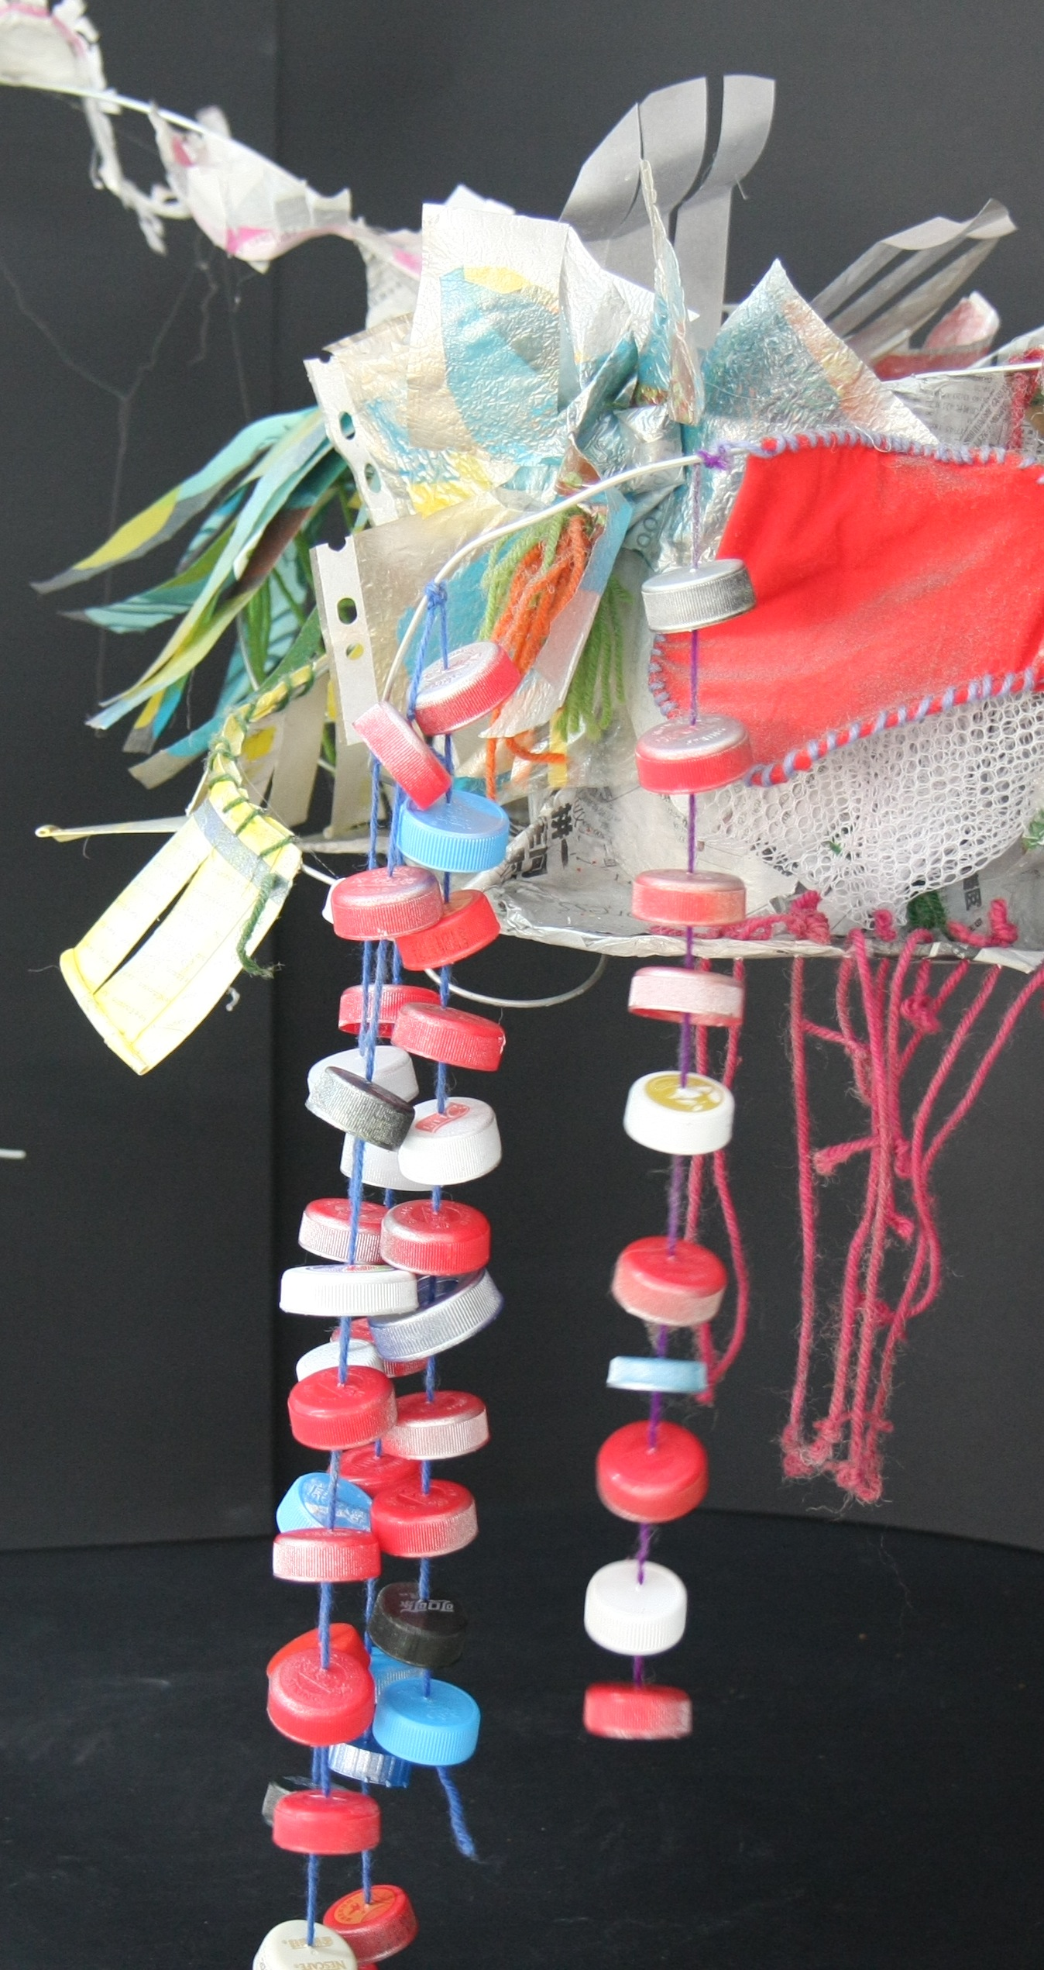
Bottle caps sewn with wool and strong needle, Wool has knots to keep caps in place
Plastic fusing cut into strips and sewn onto a wire frame
Plastic fusing cut into segments and sewn together to make a flower

